USE twitter

SELECT * FROM users

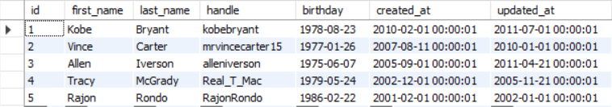

INSERT INTO `twitter`.`users` (`first_name`, `last_name`, `handle`, `birthday`, `created_at`, `updated_at`) VALUES ('Karla', 'Gutierrez', 'KaiSG', '2001-03-14',NOW(), NOW());



SELECT * FROM users

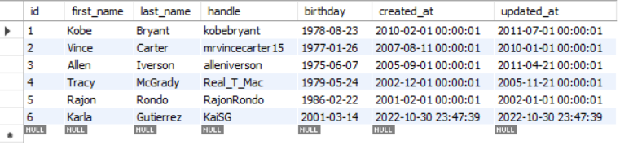

SELECT

handle, first_name, last_name

FROM users



UPDATE `twitter`.`users` SET `updated_at` = '2022-10-30 23:55:00' WHERE (`id` = '6');

UPDATE `twitter`.`users` SET `handle` = 'Karla_SG' WHERE (`id` = '6');

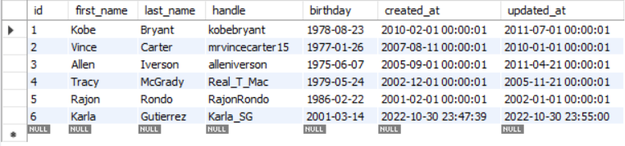

DELETE FROM `twitter`.`users` WHERE (`id` = '6');

